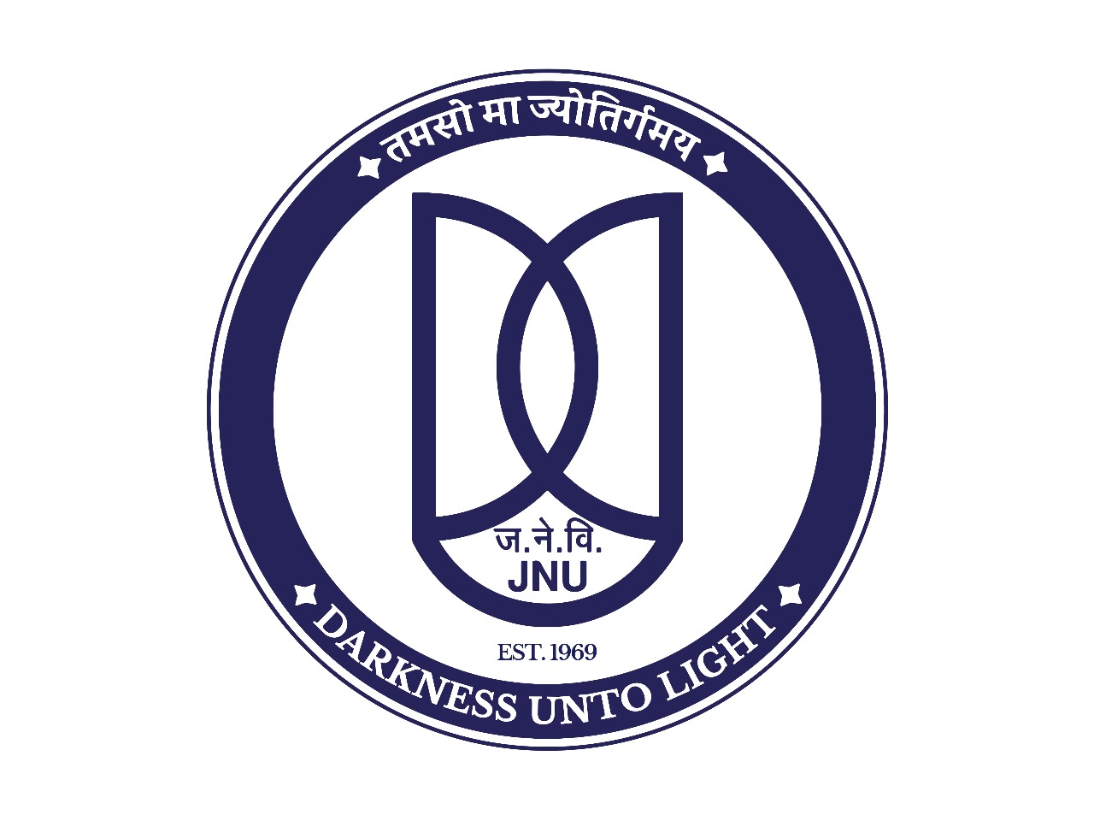
MEMORANDUM OF UNDERSTANDING

BETWEEN
JAWAHARLAL NEHRU UNIVERSITY, NEW DELHI, INDIA
AND
****************************************
Jawaharlal Nehru University, New Delhi, (hereinafter called JNU) and University **** (hereinafter called ***) establish hereby a formal understanding of cooperation and friendship which is intended to further academic objectives of each institution and to promote better understanding between the faculty and students of JNU and the faculty and students of ***. Under this Memorandum of Understanding, the two institutions will proceed to implement the following endeavors and exchanges of materials and personnel.
Areas of Cooperation
Cooperation shall be carried out, subject to availability of funds and approval of the competent authority of JNU and ***, through such activities or programmes as:
1. Exchange of faculty members
2. Exchange of students
3. Joint research activities
4. Participation in seminars and academic meetings
5. Exchange of academic materials and other information
6. Special short-term academic programmes
7. Exchange of Administrative Managers/Coordinators
8. Joint Cultural Programmes
The terms of such mutual cooperation and necessary budget for each specific programme and activity that is implemented under the terms of this MOU shall be mutually discussed and agreed upon in writing by both parties prior to the initiation of the particular programme or activity and the terms of such programme shall be negotiated on an annual basis. Each university will designate a Liaison Officer to develop and coordinate specific activities or programmes.
Scope of the Cooperation
The areas of cooperation include, subject to mutual consent, any Programme offered at either university as felt desirable and feasible on either side and that both sides can contribute to fostering and development of cooperative relationships between the two universities.
The assistance to be provided by each of the contracting parties will be teaching, research, exchange of faculty and students, and staff development, etc. as deemed beneficial by the two institutions.
The Memorandum of Understanding (MoU) shall remain in force for a period of three years from the date it is signed by the appropriate officials of the two universities. It may further be extended or amended with the written agreement of both parties. This MoU may be terminated by either party subject to the delivery of six months advance notice, in writing.
At JNU, International Collaboration office will oversee the implementation of the MoU. At ***, the **** Department will oversee the implementation of the MoU.
Both parties understand that all financial arrangements will have to be negotiated and will depend on the availability of funds.
This MoU will be executed in English language, and both will be considered as originals.

Prof. Santishree Dhulipudi Pandit
Vice Chancellor Vice Chancellor/Rector
Jawaharlal Nehru University Or Authorized representative
New Delhi Of the Institute

Dated: Dated:

